Part 1: Project Plan & Design Comps

My design plan is that the most eye-catching part of the homepage is specials. Customers will be attracted by specials and increase their desire to buy. Next to special offers are customer reviews, which can increase the favor of new users on the site. Below is the menu, click on the menu to jump to a new webpage to view the food introduction interface and prices.

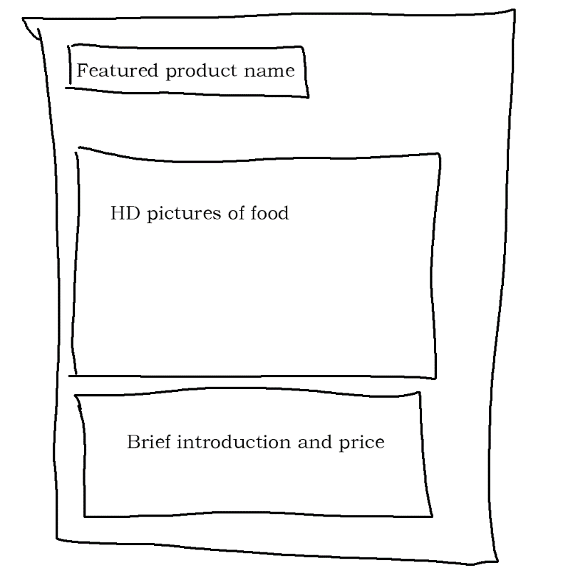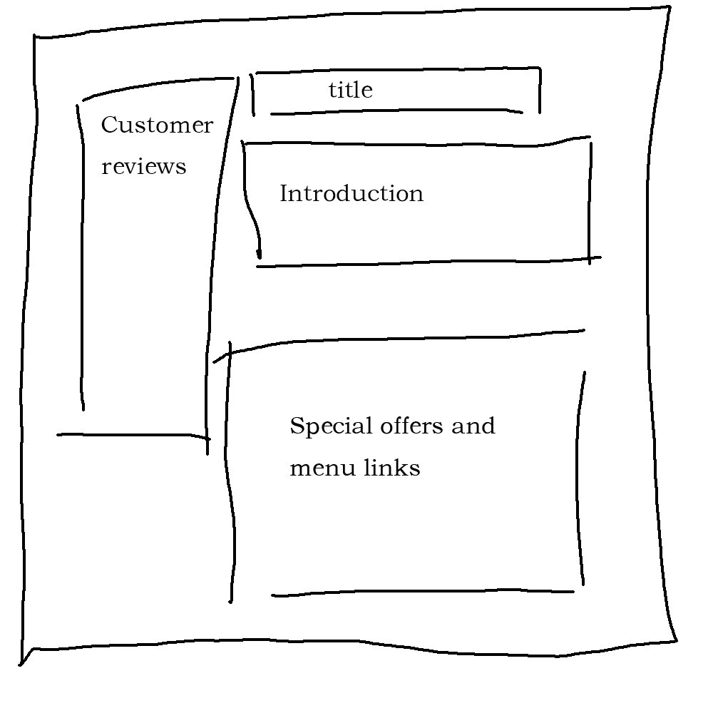

Part 2: Design Rationalisation

I chose light yellow as the background color of the main page. Light tones can make it easier for website visitors. I use a white background for the image to make the visual effect of the website more concise, and the image of discount food uses artistic fonts, which can attract the attention of visitors in the first place.

I choose to display the contact information at the bottom because visitors may want to order some desserts after viewing discounted food and specialty food menus, so visitors can directly view the contact information.

In the food introduction interface, I use high-definition large pictures to display the food to make tourists want to buy. At the same time, it also comes with a simple introduction and price. If visitors need to order some desserts, visitors can see the prices directly.

And the food introduction interface also has a return button, so that customers can easily return to the menu to view other menus and the contact information at the bottom.

A registration box is set at the bottom. Customers can register for Petite Treats Weekly newsletter by entering their name, email address, birthday, and product interest.